**Calgary Stampede**

Every season is festival season in Calgary. Festivals bring out the best in Calgary, as visitors and locals celebrate everything from culture and music to food and theatre. These must-attend festivals are perfect for planning a trip around.  

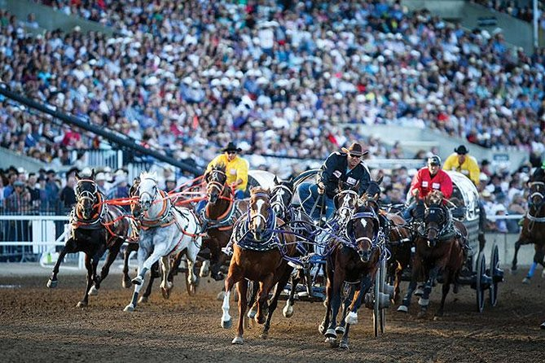

At the Calgary Stampede you will experience an event like no other. It is a rodeo, a music and arts festival, a carnival, a foodie’s paradise, and a celebration of western heritage. The first Stampede took place in 1912 with 80,000 people. Now more than 1 million visitors from around the world visit the Greatest Outdoor Show on Earth. Here is everything you need to know to have an awesome Stampede.Calgary Stampede is not just one of the best Calgary festivals, but it is also the most significant town festival. Calgary’s nicknames, Cowtown and Stampede City, owe their origins to this festival.The Stampede is a 10-day event filled with everything representing Western culture and is most famous for its televised rodeo competitions and chuckwagon racing. There are also other events such as agricultural competitions, concerts, exhibitions, and parades.The whole city participates in this festival by redecorating buildings with cowboy-themed designs. Restaurants also join by adding pancakes and barbecues to their menu. Yahoo!